**Logistic Regression for Classification**

**Some important term that are used in logistic regression**

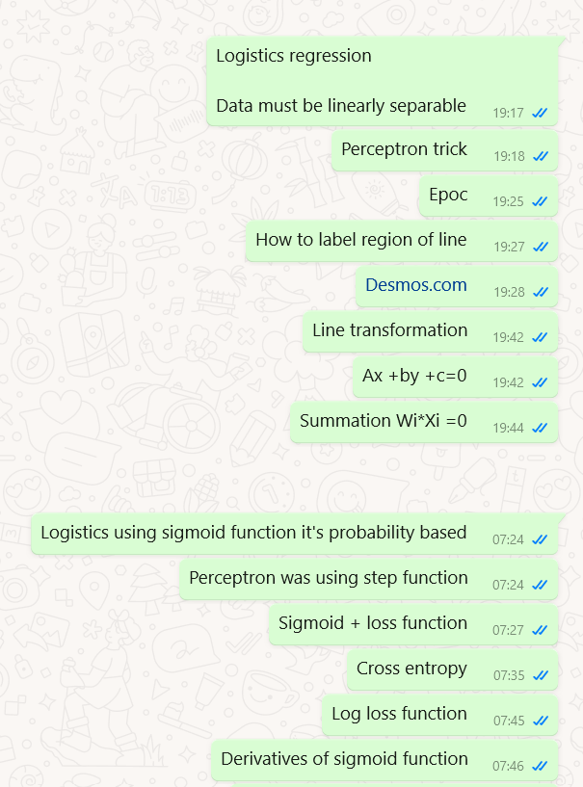

* Polynomial feature in logistics regression
* Logistics regression hyper parameters

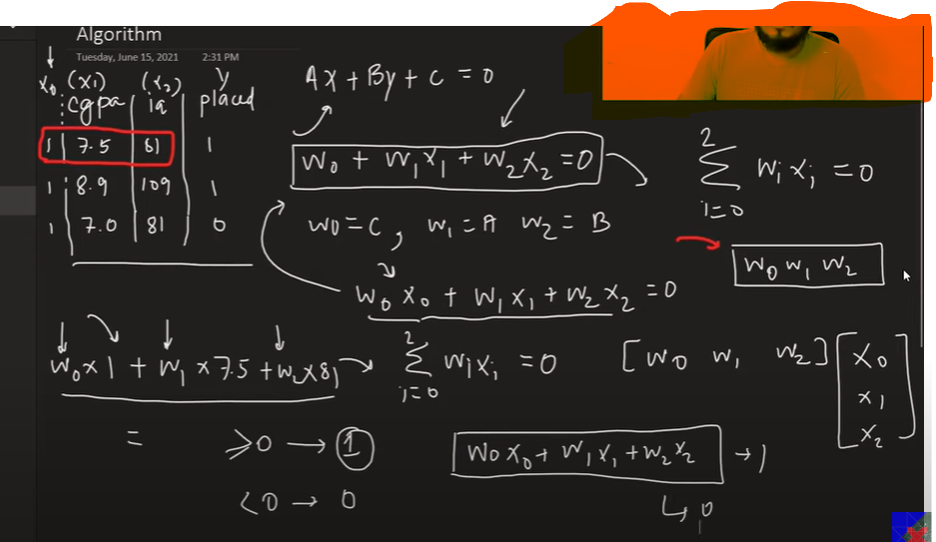

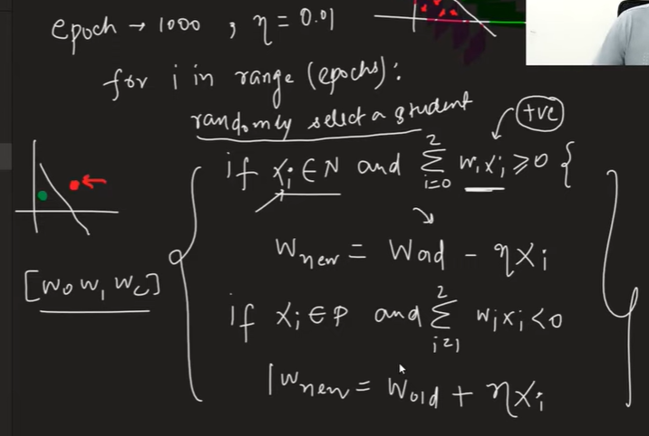

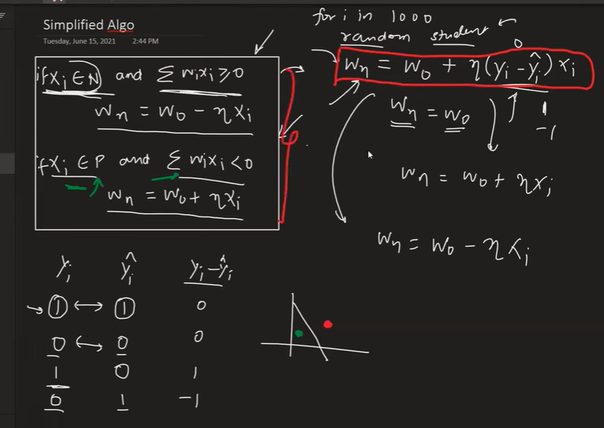

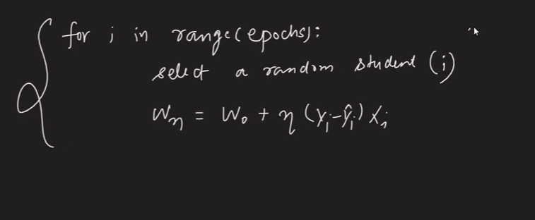

**This approach have some issues**

**Use sigmoid instead of step function**

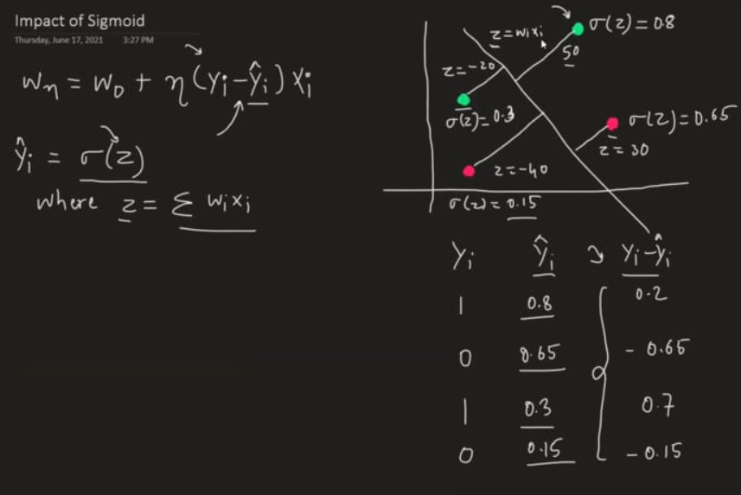

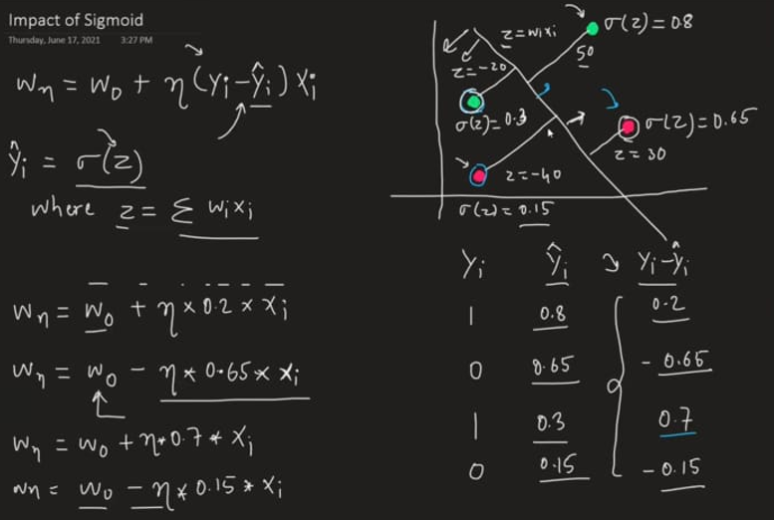

**Using sigmoid still we are not getting perfect predicted line which can divide both blue and green point from the middle so we need a loss function to calculate minima which can tell this line has the minimum loss**

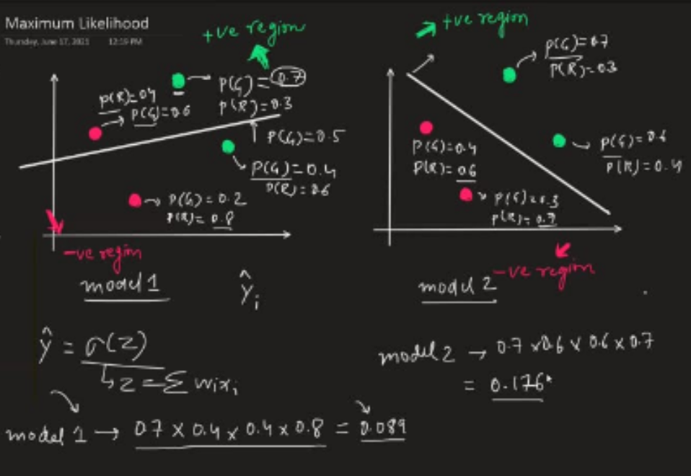

**Log loss function**

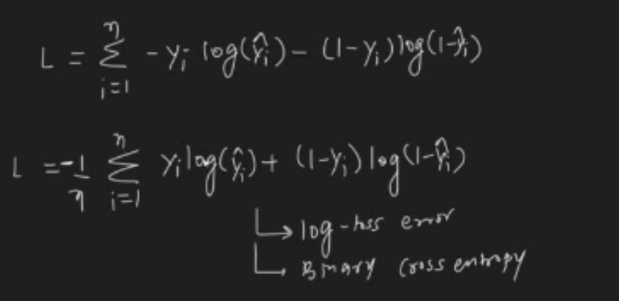

**Derivative of log loss function (using gradient decent)**

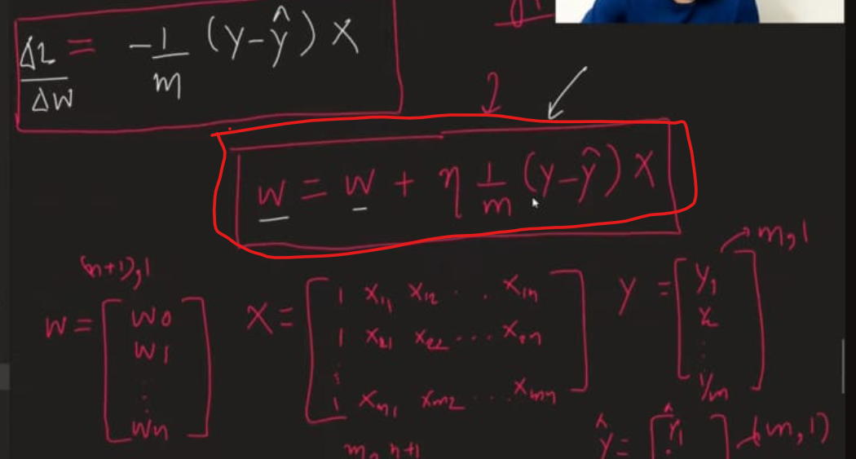

**We can use this formula to write python code which will work like sklearn**

**Code -** [**https://github.com/campusx-official/100-days-of-machine-learning/tree/main/day58-logistic-regression**](https://github.com/campusx-official/100-days-of-machine-learning/tree/main/day58-logistic-regression)